Chapter 5, Problem 64

For the op amp circuit shown in Fig. 5.91, find v_{o}/v_{s}.

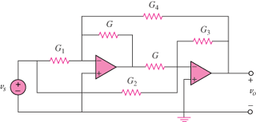

Figure 5.91
For Prob. 5.64.

